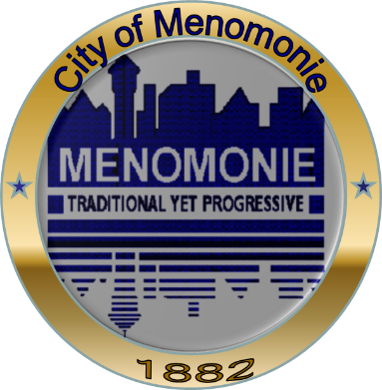
The City of Menomonie Treasurer’s Office is working with the Dunn County Humane Society to encourage City of Menomonie residents to license dogs and cats.
Beginning April 1st, 2014 you can purchase your dog or cat license, along with your dog park pass at the Dunn County Humane Society or the City Treasurer’s Office.
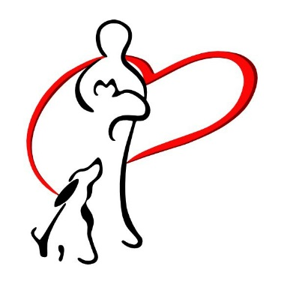
Licensing your pets helps us get lost pets back to their home much more quickly.
Any questions, please contact the City of Menomonie at 715-232-2221 or the Dunn County Humane Society at
715-232-9790.

